The New Beginnings Community Baptist Church
Pastor’s Aide Ministry & The New Beginnings Alliance Women’s Group
Presents
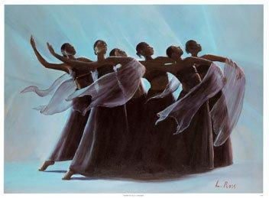

PRAISE HIM
~IN A DANCE~
Recital


SATURDAY, APRIL 18, 2015
4 o’clock pm
YOU DON’T WANT TO MISS THIS!

Faith Assembly of God
1926 Margaret St.
Phila. PA 19124

Free Will Offering

